姓名：唐璐 | 专业：信息管理与信息系统 | 班级：20181171 | 学号：2018117135
科目： 安卓 |  | 实验日期：2021/6/22
实验题目：
【实验目的】

【实验环境及方式】
- 创建项目BroadcastTest
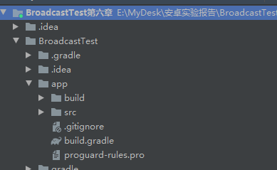
- 修改mainActivity文件的内容

@Override
protected void onCreate(Bundle savedInstanceState) {
super.onCreate(savedInstanceState);
setContentView(R.layout.activity_main);
// intentFilter = new IntentFilter();
// intentFilter.addAction("android.net.conn.CONNECTIVITY_CHANGE");
// networkChangeReceiver = new NetworkChangeReceiver();
// registerReceiver(networkChangeReceiver, intentFilter);
localBroadcastManager = LocalBroadcastManager.getInstance(this); // 获取实例
intentFilter = new IntentFilter();
intentFilter.addAction("com.example.broadcasttest.LOCAL_BROADCAST");
localReceiver = new LocalReceiver();
localBroadcastManager.registerReceiver(localReceiver, intentFilter); //动态 注册本地广播监听器
Button button = (Button) findViewById(R.id.button);
button.setOnClickListener(new View.OnClickListener() {
@Override
public void onClick(View v) {
Intent intent = new Intent("com.example.broadcasttest.MY_BROADCAST");
sendBroadcast(intent);
intent = new Intent("com.example.broadcasttest.LOCAL_BROADCAST");
localBroadcastManager.sendBroadcast(intent);
}
});
}
@Override
protected void onDestroy() {
super.onDestroy();
// unregisterReceiver(networkChangeReceiver);
localBroadcastManager.unregisterReceiver(localReceiver);
}
class LocalReceiver extends BroadcastReceiver {
@Override
public void onReceive(Context context, Intent intent) {
Toast.makeText(context, "成功接收自定义局部广播！", Toast.LENGTH_SHORT).show();
}
}

- AndroidMainfest.xml文件

<?xml version="1.0" encoding="utf-8"?>
<manifest xmlns:android="http://schemas.android.com/apk/res/android"
package="com.example.broadcasttest">
<uses-permission android:name="android.permission.ACCESS_NETWORK_STATE" />
<uses-permission android:name="android.permission.RECEIVE_BOOT_COMPLETED" />
<application
android:allowBackup="true"
android:icon="@mipmap/ic_launcher"
android:label="@string/app_name"
android:supportsRtl="true"
android:theme="@style/AppTheme">
<activity android:name=".MainActivity">
<intent-filter>
<action android:name="android.intent.action.MAIN" />
<category android:name="android.intent.category.LAUNCHER" />
</intent-filter>
</activity>
<receiver
android:name=".BootCompleteReceiver"
android:enabled="true"
android:exported="true">
<intent-filter>
<action android:name="android.intent.action.BOOT_COMPLETED" />
</intent-filter>
</receiver>
<receiver
android:name=".MyBroadcastReceiver"
android:enabled="true"
android:exported="true">
<intent-filter android:priority="100">
<action android:name="com.example.broadcasttest.MY_BROADCAST"/>
</intent-filter>
</receiver>
</application>
</manifest>

四、运行代码
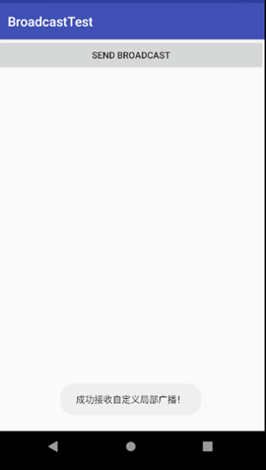

【教师评语和成绩】

成绩： 指导教师： 日期：

